**MESF6910J, Term 2, 2017-2018**

**Assignment #4:**

**Topology Optimization of a Michell-Type Structure (Part 2)**

***Due: 7 PM, 26 April, Thursday***

*The structure*: A Michell-type structure is considered with three loads at its bottom, spaced in equal distance between the two supports, as shown in the Figure. The rectangular design domain is with . The structure has a fixed and a simple support at the bottom corners. The loads are  and . The material has a modulus of elasticity of 100 Mpa and the Poisson’s ratio of = 0.3. This structure is fully described in Assignment #1.

*The problem*: In the topology optimization using the SIMP method for the minimization of the strain energy function c as defined in the lecture. For this assignment, sensitivity filtering is employed by setting suitable parameter “rmin”. You shall conduct the following studies:

1. The parameter “penal” is set to equal to 3. “volfrac” is the volume fraction, and it is specified to be 0.30. “rmin” is set to equal to 1.5 times of the width of an FEM element. You will find optimal design for the two cases of finite element mesh and show your optimal design in grey-scale.
   1. A mesh of  quadrilateral elements will be used.

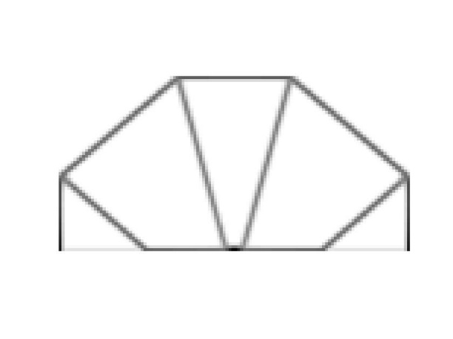

Top99_120_60(120, 60, 0.3, 3, 1.5)

It.: 56Obj.: 0.0107 Vol.: 0.054 ch.: 0.096

* 1. A mesh of  quadrilateral elements will beused.

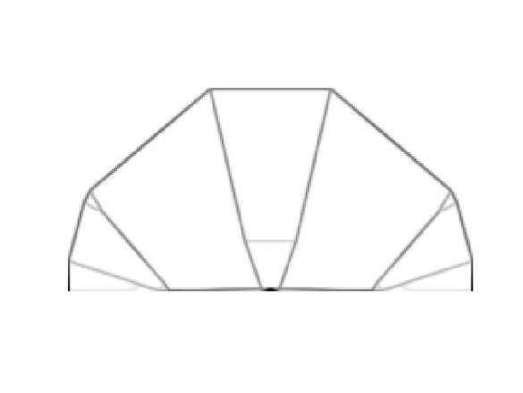

Top99_240_120(240, 120, 0.3, 3, 1.5)

It.: 51Obj.: 0.0231 Vol.: 0.030 ch.: 0.200

1. The parameter “penal” is set to equal to 3. “volfrac” is the volume fraction, and it is specified to be 0.30. “rmin” is set to equal to 3.0 times of the width of an FEM element. You will find optimal design for the two cases of finite element mesh and show your optimal design in grey-scale.
   1. A mesh of  quadrilateral elements will be used.

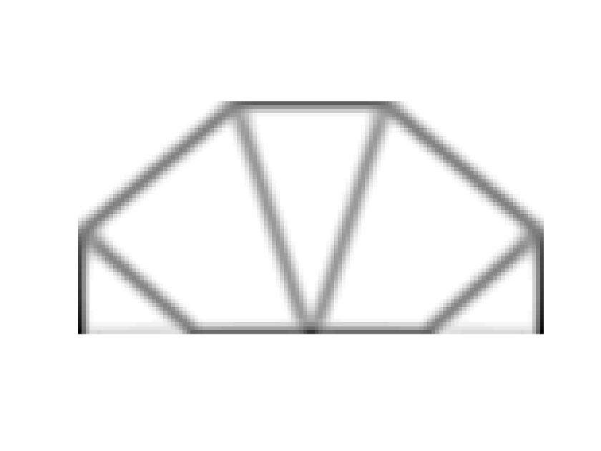

Top99_120_60(120, 60, 0.3, 3, 3)

Move lift = 0.05

It.: 98Obj.: 0.0166 Vol.: 0.075 ch.: 0.022 (converged)

* 1. A mesh of  quadrilateral elements will be used.

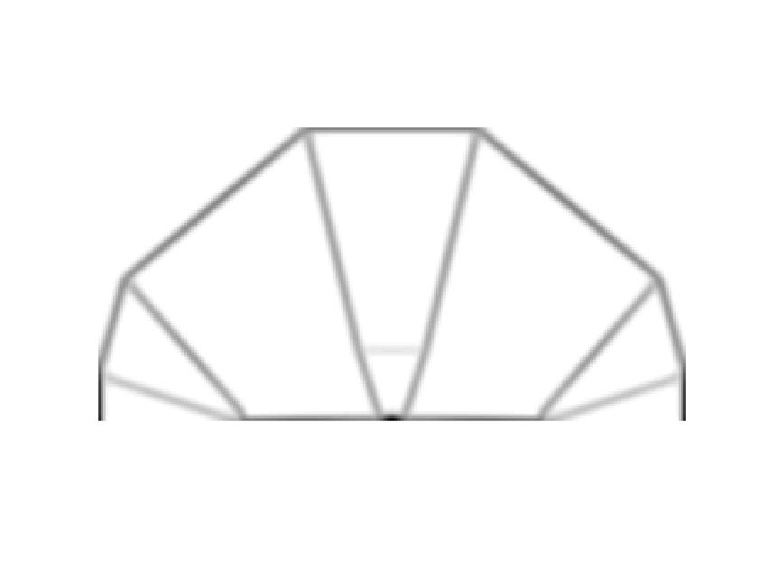

Top99_240_120(240, 120, 0.3, 3, 3)

It.: 45Obj.: 0.0299 Vol.: 0.039 ch.: 0.200

1. Based on the designs you have obtained above, briefly discuss the effects of the filter parameter “rmin” and the FEM mesh on the obtained optimization results.

The filter parameter rmin effect the microstructure of the topology. The bigger filter makes the structure more even. The microstructures which originally existed in the small filter rmin cases become disappear in the bigger rmin cases.

The FEM mesh also influence the structure’s topology.